

**UNIVERSITY TUNKU ABDUL RAHMAN**

**FACULTY OF SCIENCE**

**UDPS 2233 MULTIVARIATE ANALYSIS**

**ASSIGNMENT 1**

**TRIMESTER MAY 2019**

**Course Details**

**Course : SC**

**Lecturer : Ms.Kavitha a/p Subramaniam**

**Student Details**

|  |  |  |  |
| --- | --- | --- | --- |
| **No** | **Name** | **Student ID** | **Year Study** |
| 1 | Cheong Wei Shan | 17ADB04494 | Y2S1 |
| 2 | Choo Jia Wei | 16ADB02865 | Y2S3 |
| 3 | Lee Chun Hao | 17ADB03582 | Y2S1 |
| 4 | Ngu Yi Hui | 18ADB01438 | Y2S1 |
| 5 | Teng Yen Lin | 18ADB00579 | Y2S2 |
| 6 | Wong Zhen Yang | 17ADB02232 | Y2S1 |

**Assignment 1**

i ) 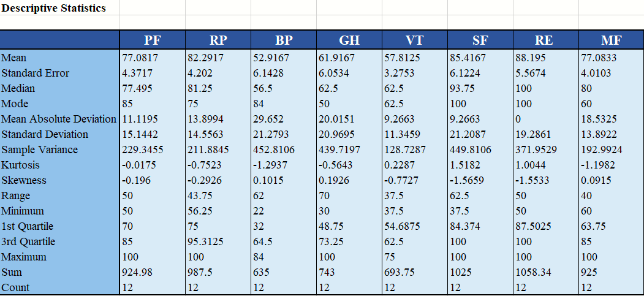

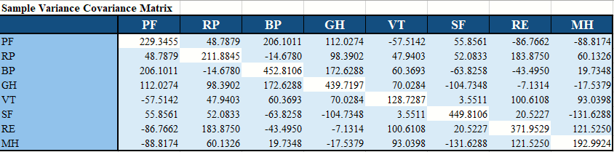

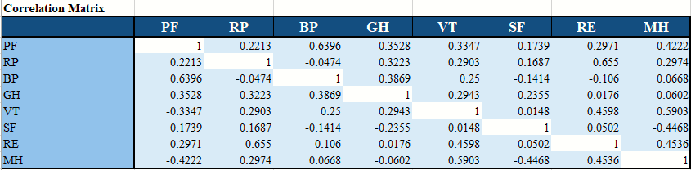

From the correlation matrix, we can observe that the relationships between the variables. First of all, we will explain the relationship between physical functioning (PF) with other factors. The correlation coefficient between PF with RP and PF with SF are 0.2213 and 0.1739 respectively, which show both of them are having a weak positive relationship with PF. The factor PF has a correlation coefficient of 0.6396 with BP which shows that the two factors have a moderate positive relationship. Together with GH, a value of 0.3528 is achieved and this indicates a weak positive relationship. Both VT and RE have a weak negative relationship with PF which are correlation coefficients of -0.3347 and -0.2971 respectively. While for MH, its correlation value with PF is -0.4222 means they are having a moderate negative relationship.

For the factor role physical (RP), it has a value of -0.0474 which shows a very weak negative relationship with BP. Four variables GH, VT, SF and MH all indicates a weak positive relationship with RP which can be proved by their correlation values 0.3223, 0.2903, 0.1687, and 0.2974 respectively. For the correlation of RP and RE, coefficient of 0.655 was obtained that shows they are moderate positive relationship.

For the factor body pain (BP), the variables GH and VT are found to have the correlation coefficient of 0.3869 and 0.25 with BP. These values show that both GH and VT have a weak positive relationship with BP. While for the variable SF and RE, -0.1414 and -0.106 are computed to be their correlation values with BP. The results explain that they have a weak negative relationship with BP. Variable MH has a correlation value of 0.00668 with BP that indicates their relationship is positive but very weak.

For the factor general health (GH), its relationship with VT is weak and positive which can be illustrated by the correlation value of 0.2943. On the other hand, the relationship of GH with SF, RE and MH are weak and negative which can be observed by the correlation coefficient of -0.2355, -0.0.176, -0.0602.

For the factor vitality (VT), it has a very weak positive relationship with SF which is only correlation value of 0.0148. While for the variables RE and MH, the relationships appear to be moderate and positive as their correlation values with VT are 0.4598 and 0.5903 respectively.

For the factor social function (SF), the correlation coefficient calculated with RE is 0.0502 which shows that it has a very weak positive relationship. The correlation coefficient of SF and MH is -0.4468 that gives the information about it is a moderate negative relationship.

Lastly, for the factor role emotional (RE) and mental health (MH), the correlation between these two variables is 0.4536 which indicates that the relationship is moderate and positive.

ii ) 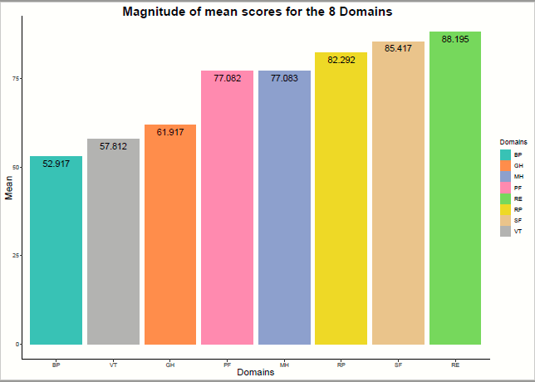

iii ) 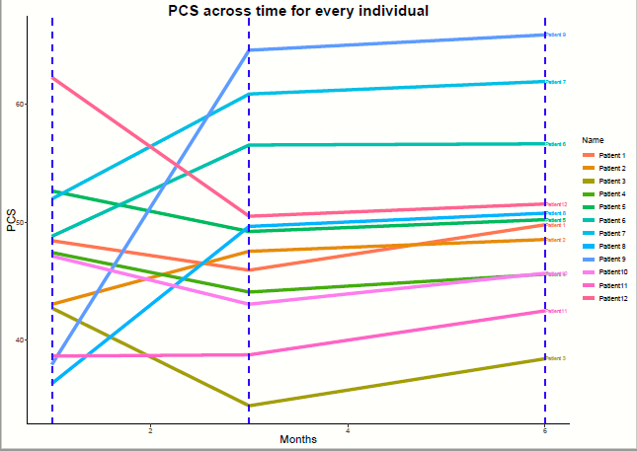

iv ) From the figure, it clearly shows that the Physical Component Score (PCS) of the patients are changing in three states, which are increase, decrease, and constant after the first follow-up. PCS of 5 patients had increased while 6 patients had decreased. There was only 1 patient’s PCS remain constant. On the other hand, after the second follow-up, the PCS of the patients are changing in two states, which are increase and constant. There was 2 patients’ PCS remain constant and the others were increasing fairly. In overall, the PCS of the patients will be increased after the second follow-up if their score decreased initially. Thus, the majority of the patients got their PCS to be increase slowly after the second follow-up.